### Step-by-Step Guide to Deploy Keycloak Locally:

1. Install Java (if not already installed)

First, check if Java is installed by running: **java -version**

if not installed, then use these commands**:**

**sudo apt update**

**sudo apt install openjdk-17-jdk**

1. **Download Keycloak**: https://www.keycloak.org/downloads
2. Extract the Keycloak Archive file
3. **Navigate to the Keycloak directory**:

cd /home/jyoti/keycloak-26.1.4

1. **Start Keycloak Server for Development**:

./bin/kc.sh start-dev

1. Access Keycloak Admin Console:

By default, Keycloak will run on http://localhost:8080

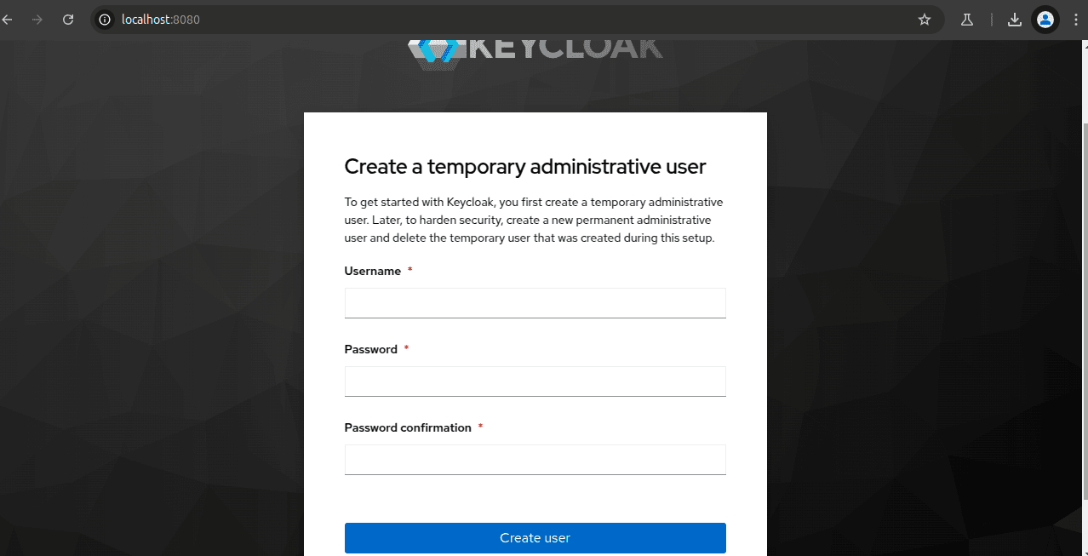

1. Create an admin user and credentials:
2. Sign in to the account;

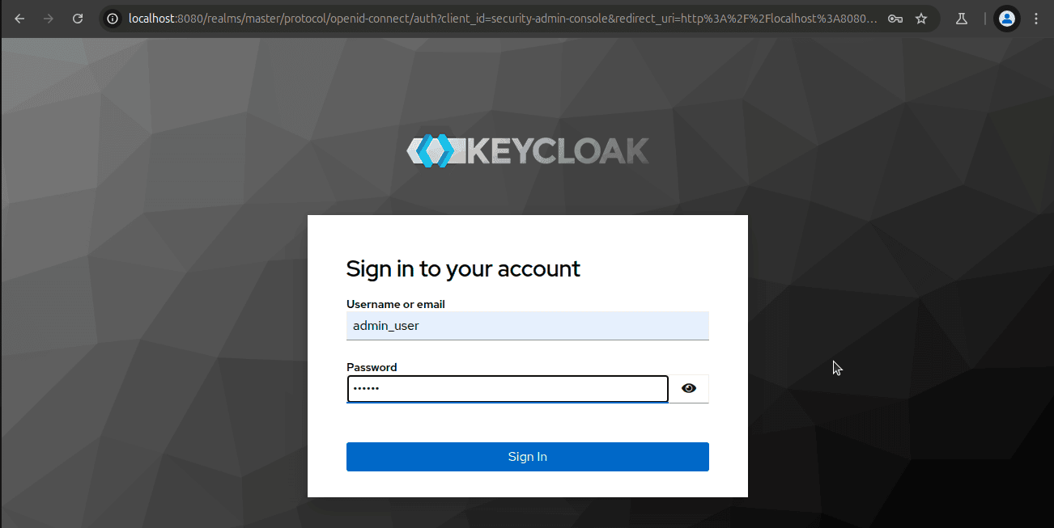

1. Dashboard screen:

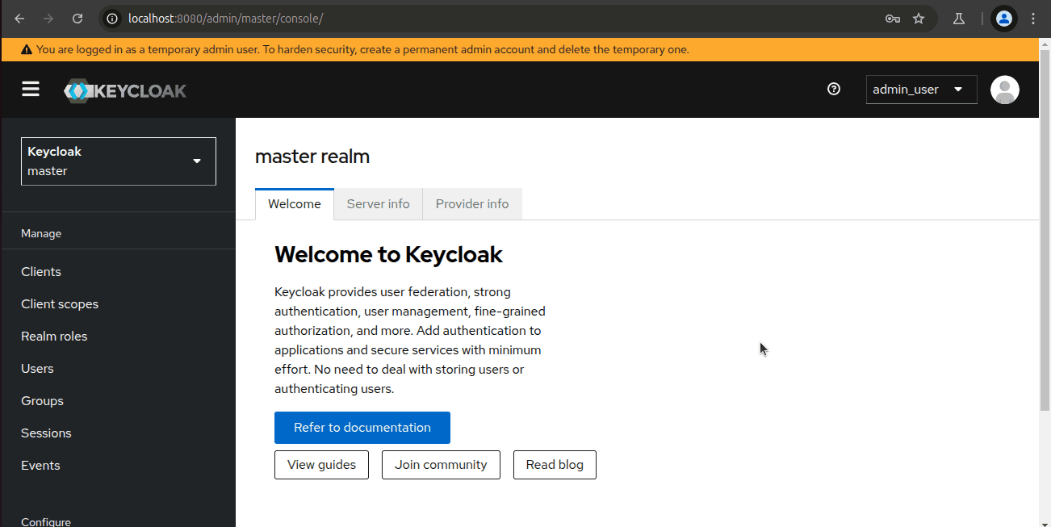

1. Create Realm

Click on the master->create realm

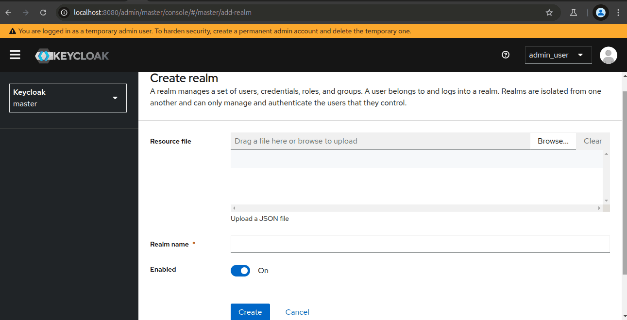

Enter your realm name and save it.

1. Create user inside the realm:
   1. Make sure you are in the created realm -> users from left pane -> create user ->
   2. Enter username, first name, and last name -> click create

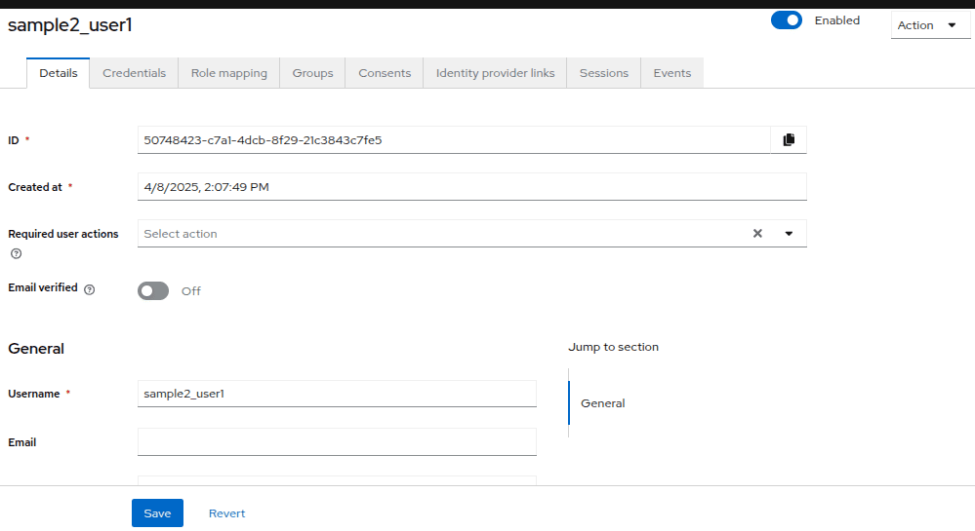

c. click on the credentials at the top -> set password ->

1. Secure the first application
   1. Click the word **master** in the top-left corner, then click **your realm**
   2. click **client** -> click **create client** -> Fill in the form

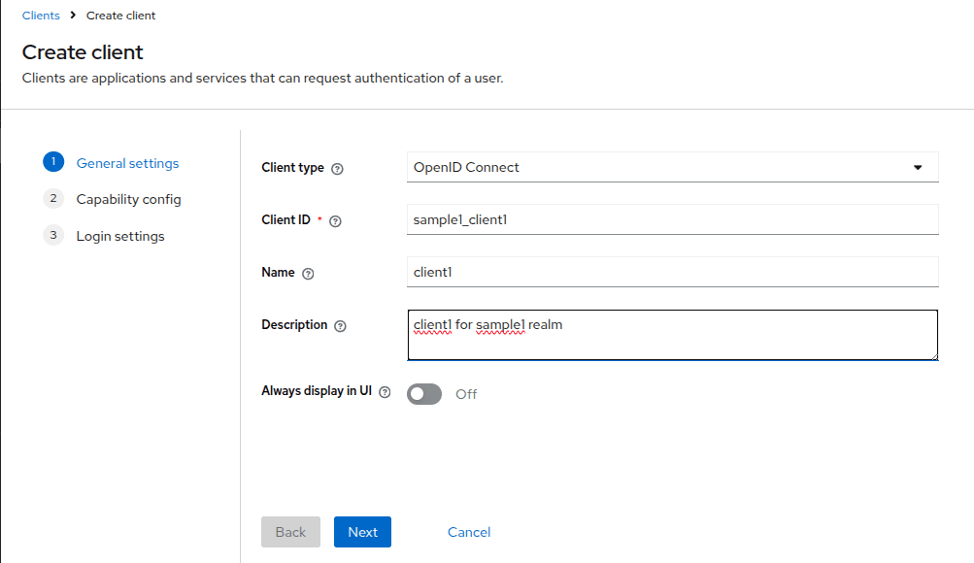

click **Next** ->

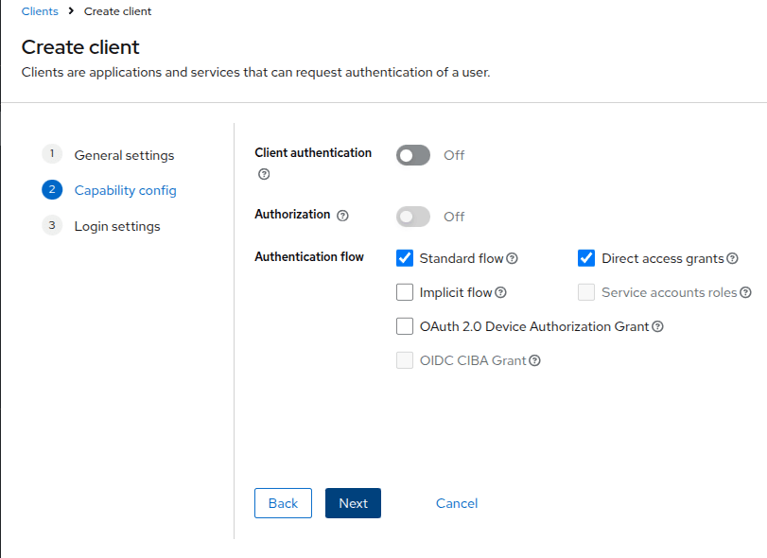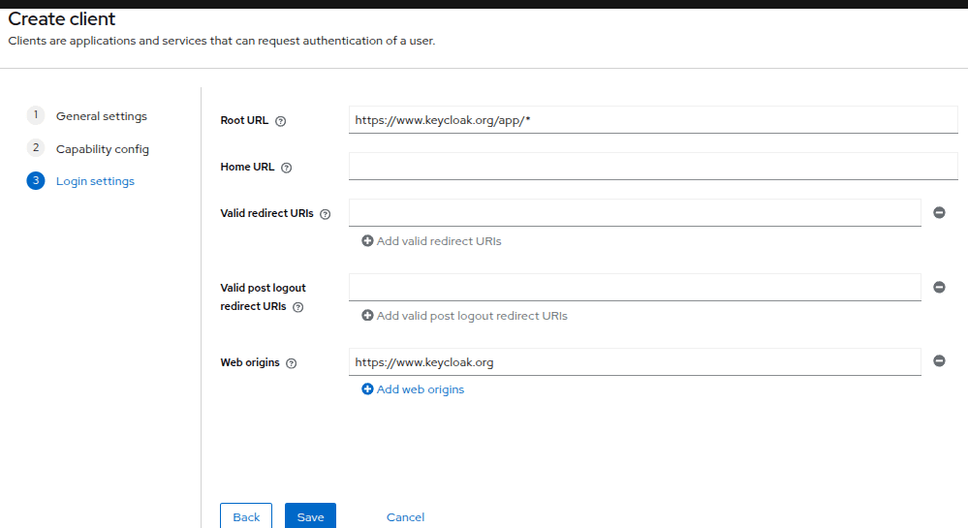

Click **Save**. You will get the message client created successfully.